* **Write SQL query to solve the problem given below:-**

**Create table:-**

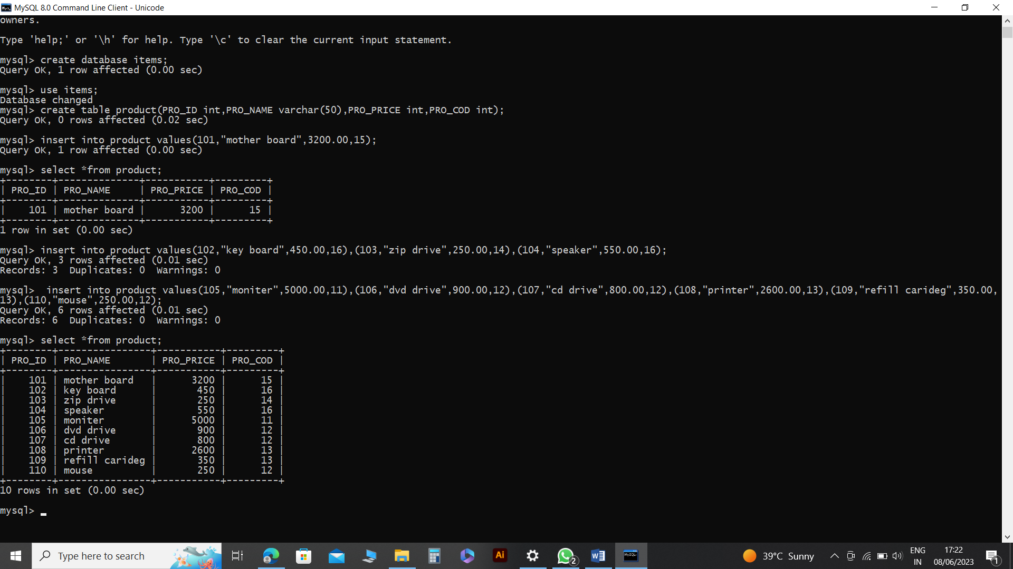

* Write sql query to find the items whose prices are higher than or equal 250rs. Order the result by product price in descending, then product name in ascending. Return pro_name and pro_price.

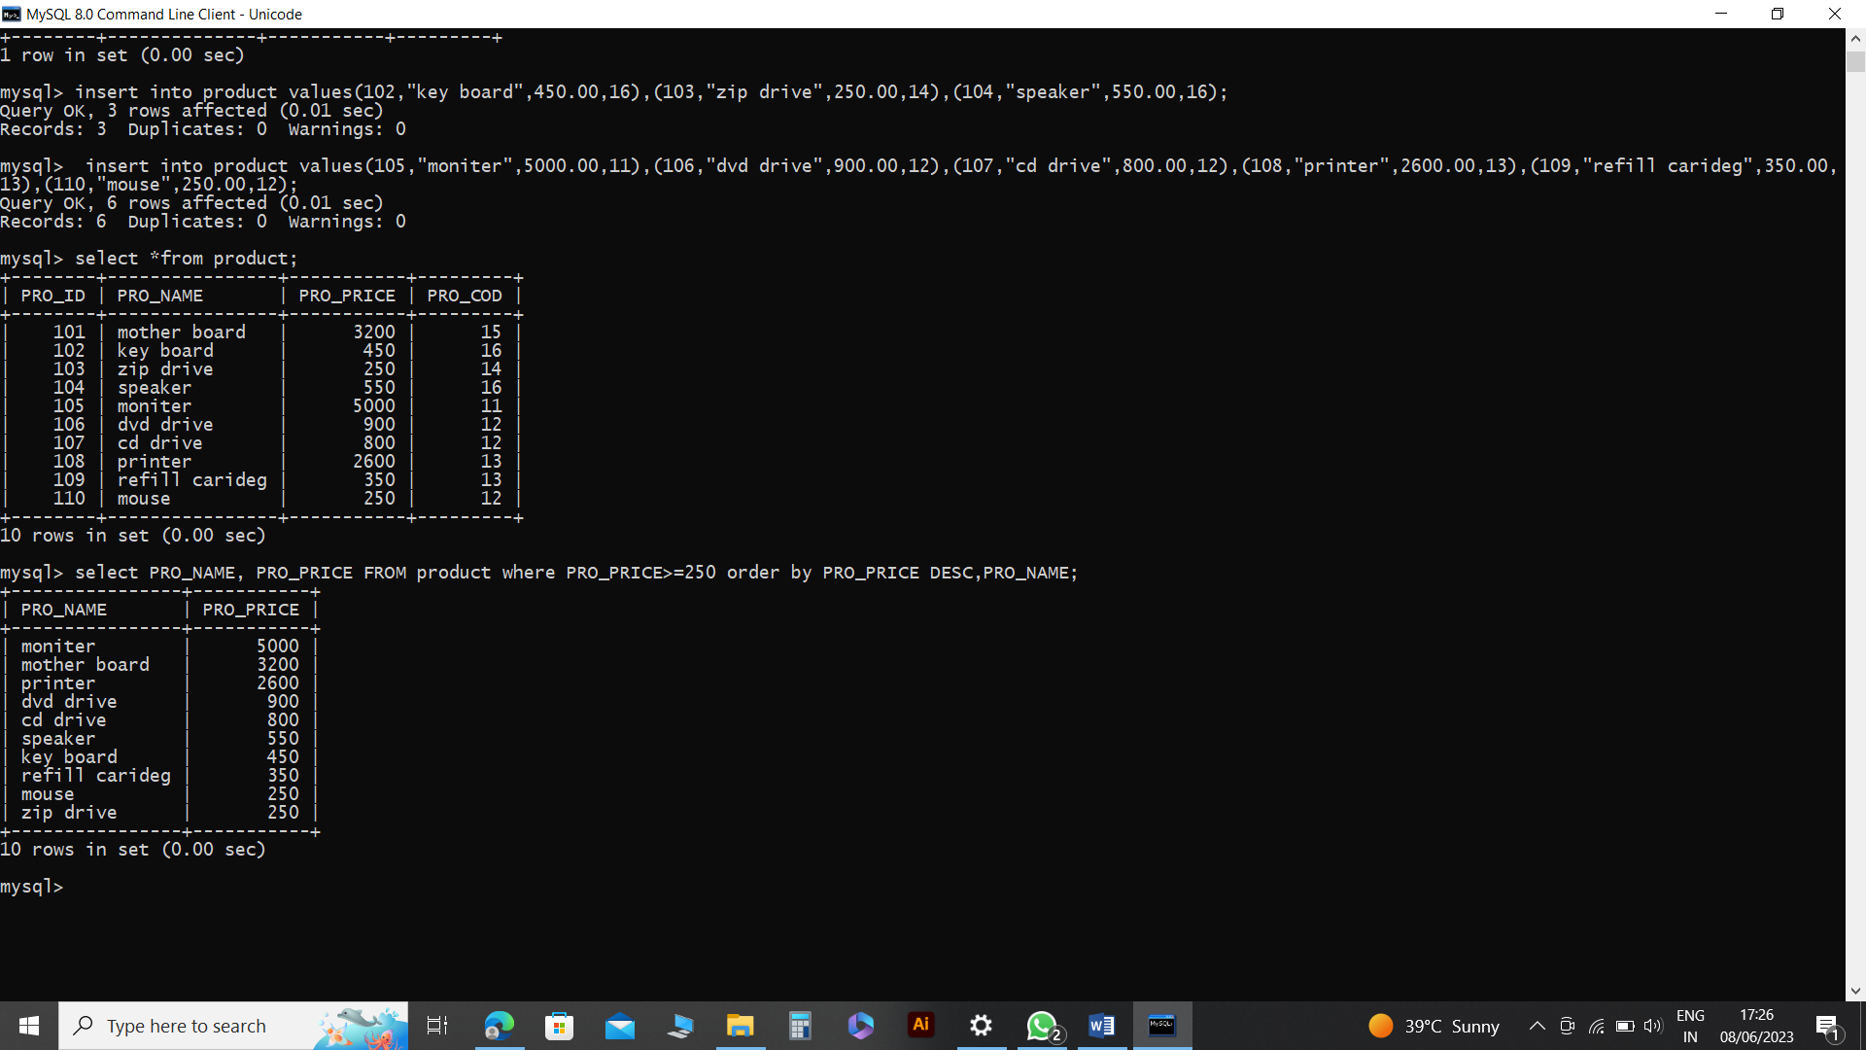

* Write the sql query to calculate the average price of the items for each company. Return average price and company code.

● Write the sql query to find the average total for all the product mention in the table

